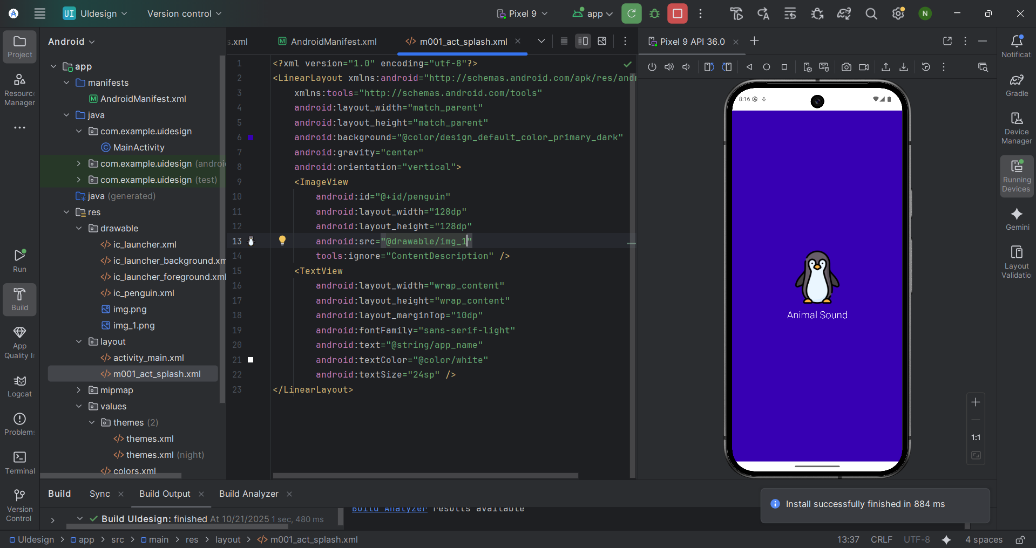
AndroidManifest
<?xml version="1.0" encoding="utf-8"?>
<manifest xmlns:android="http://schemas.android.com/apk/res/android"
xmlns:tools="http://schemas.android.com/tools">
<application
android:allowBackup="true"
android:dataExtractionRules="@xml/data_extraction_rules"
android:fullBackupContent="@xml/backup_rules"
android:icon="@mipmap/ic_launcher"
android:label="@string/app_name"
android:roundIcon="@mipmap/ic_launcher_round"
android:supportsRtl="true">
<activity
android:name=".MainActivity"
android:exported="true"
android:theme="@style/Full_Screen">
<intent-filter>
<action android:name="android.intent.action.MAIN" />
<category android:name="android.intent.category.LAUNCHER" />
</intent-filter>
</activity>
</application>
</manifest>
Main Activity
package com.example.uidesign;
import android.os.Bundle;
import androidx.activity.EdgeToEdge;
import androidx.appcompat.app.AppCompatActivity;
import androidx.core.graphics.Insets;
import androidx.core.view.ViewCompat;
import androidx.core.view.WindowInsetsCompat;
public class MainActivity extends AppCompatActivity {
@Override
protected void onCreate(Bundle savedInstanceState) {
super.onCreate(savedInstanceState);
EdgeToEdge.enable(this);
setContentView(R.layout.m001_act_splash);
ViewCompat.setOnApplyWindowInsetsListener(findViewById(android.R.id.content), (v, insets) -> {
Insets systemBars = insets.getInsets(WindowInsetsCompat.Type.systemBars());
v.setPadding(systemBars.left, systemBars.top, systemBars.right, systemBars.bottom);
return insets;
});
}
}
M001_act_splash.xml
<?xml version="1.0" encoding="utf-8"?>
<LinearLayout xmlns:android="http://schemas.android.com/apk/res/android"
xmlns:tools="http://schemas.android.com/tools"
android:layout_width="match_parent"
android:layout_height="match_parent"
android:background="@color/design_default_color_primary_dark"
android:gravity="center"
android:orientation="vertical">
<ImageView
android:id="@+id/penguin"
android:layout_width="128dp"
android:layout_height="128dp"
android:src="@drawable/img_1"
tools:ignore="ContentDescription" />
<TextView
android:layout_width="wrap_content"
android:layout_height="wrap_content"
android:layout_marginTop="10dp"
android:fontFamily="sans-serif-light"
android:text="@string/app_name"
android:textColor="@color/white"
android:textSize="24sp" />
</LinearLayout>
Themes.xml
<resources xmlns:tools="http://schemas.android.com/tools">
<!-- Base application theme. -->
<style name="Full_Screen" parent="Theme.MaterialComponents.DayNight.NoActionBar"> <!-- Customize your light theme here. -->
<!-- <item name="colorPrimary">@color/my_light_primary</item> -->
</style>
</resources>
Color.xml
<?xml version="1.0" encoding="utf-8"?>
<resources>
<color name="purple_200">#FFBB86FC</color>
<color name="purple_500">#FF6200EE</color>
<color name="purple_700">#FF03DAC5</color>
<color name="teal_200">#FF03DAC5</color>
<color name="teal_500">#FF03DAC5</color>
<color name="black">#FF000000</color>
<color name="white">#FFFFFFFF</color>
<color name="green">#FF00FF00</color>
</resources>
Stringss.xml
<resources>
<string name="app_name">Animal Sound</string>
</resources>
Bài 2
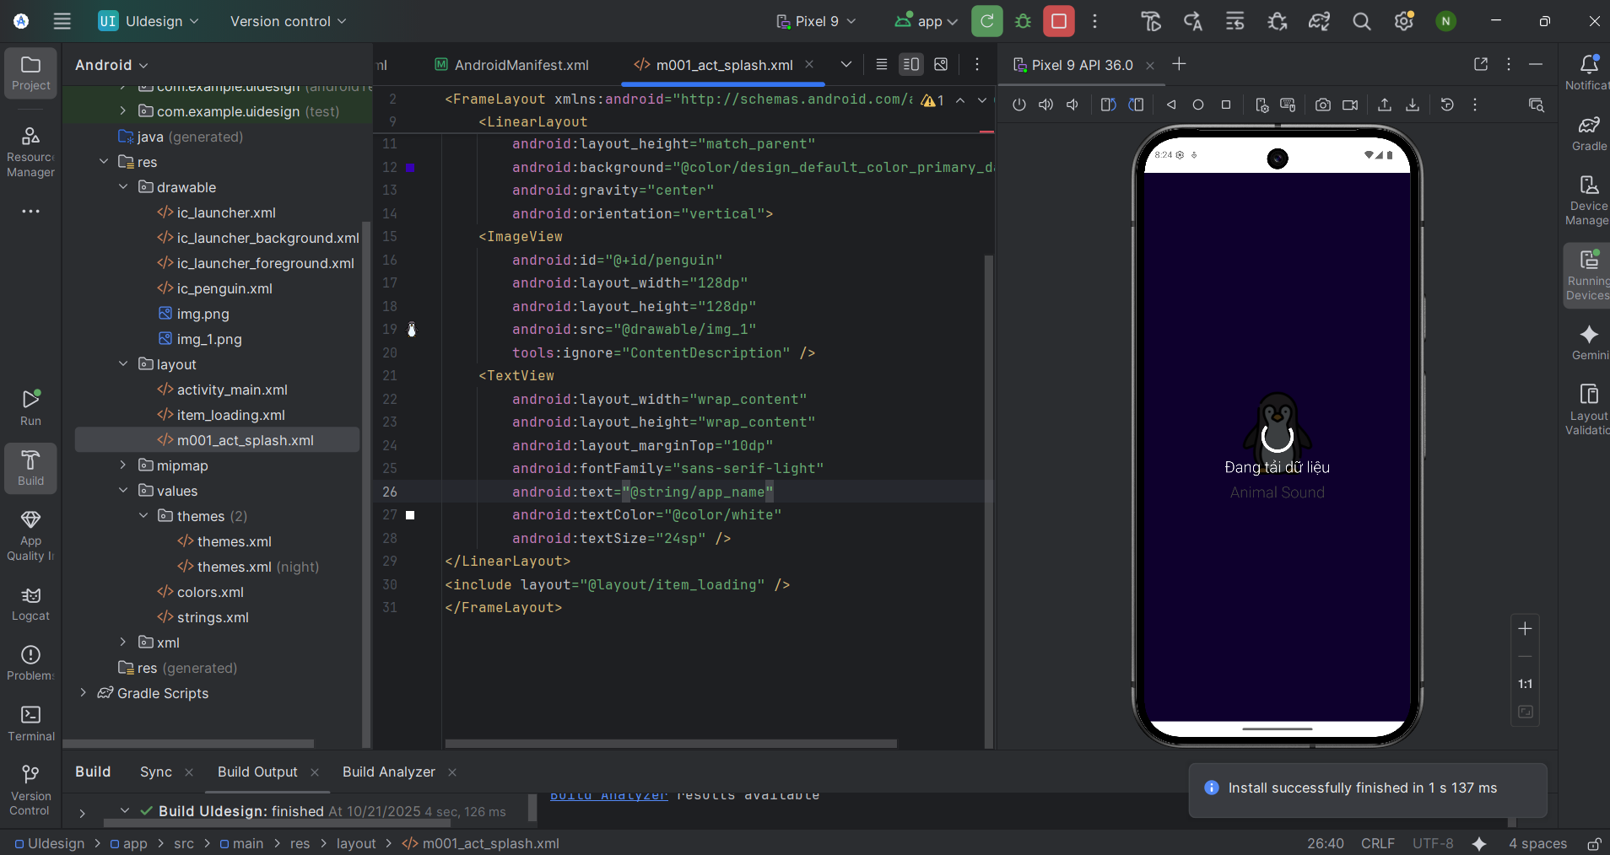
M001_act_plash.xml
<?xml version="1.0" encoding="utf-8"?>
<FrameLayout xmlns:android="http://schemas.android.com/apk/res/android"
xmlns:tools="http://schemas.android.com/tools"
android:layout_width="match_parent"
android:layout_height="match_parent"
android:background="@color/design_default_color_primary_dark"
android:gravity="center"
android:orientation="vertical">
<LinearLayout
android:layout_width="match_parent"
android:layout_height="match_parent"
android:background="@color/design_default_color_primary_dark"
android:gravity="center"
android:orientation="vertical">
<ImageView
android:id="@+id/penguin"
android:layout_width="128dp"
android:layout_height="128dp"
android:src="@drawable/img_1"
tools:ignore="ContentDescription" />
<TextView
android:layout_width="wrap_content"
android:layout_height="wrap_content"
android:layout_marginTop="10dp"
android:fontFamily="sans-serif-light"
android:text="@string/app_name"
android:textColor="@color/white"
android:textSize="24sp" />
</LinearLayout>
<include layout="@layout/item_loading" />
</FrameLayout>
Item_loanding.xml
<?xml version="1.0" encoding="utf-8"?>
<LinearLayout xmlns:android="http://schemas.android.com/apk/res/android"
android:layout_width="match_parent"
android:layout_height="match_parent"
android:gravity="center"
android:background="#BF000000"
android:orientation="vertical">
<ProgressBar
android:layout_width="60dp"
android:layout_height="60dp"
android:indeterminateTint="@color/white" />
<TextView
android:layout_width="wrap_content"
android:layout_height="wrap_content"
android:fontFamily="sans-serif-light"
android:text="@string/txt_loading"
android:textColor="@color/white"
android:textSize="24sp" />
</LinearLayout>
Bài 3
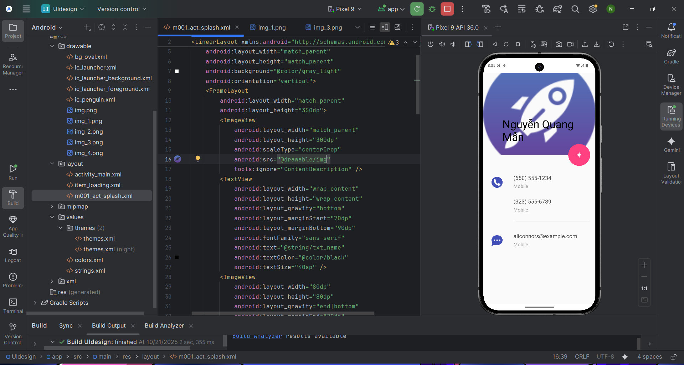
Bg_oval.xml
<?xml version="1.0" encoding="utf-8"?>
<shape xmlns:android="http://schemas.android.com/apk/res/android"
android:shape="oval">
<solid android:color="#FF4181" />
</shape>
M001_act_splash.xml
<?xml version="1.0" encoding="utf-8"?>
<LinearLayout xmlns:android="http://schemas.android.com/apk/res/android"
xmlns:app="http://schemas.android.com/apk/res-auto"
xmlns:tools="http://schemas.android.com/tools"
android:layout_width="match_parent"
android:layout_height="match_parent"
android:background="@color/gray_light"
android:orientation="vertical">
<FrameLayout
android:layout_width="match_parent"
android:layout_height="350dp">
<ImageView
android:layout_width="match_parent"
android:layout_height="300dp"
android:scaleType="centerCrop"
android:src="@drawable/img"
tools:ignore="ContentDescription" />
<TextView
android:layout_width="wrap_content"
android:layout_height="wrap_content"
android:layout_gravity="bottom"
android:layout_marginStart="70dp"
android:layout_marginBottom="90dp"
android:fontFamily="sans-serif"
android:text="@string/txt_name"
android:textColor="@color/black"
android:textSize="40sp" />
<ImageView
android:layout_width="80dp"
android:layout_height="80dp"
android:layout_gravity="end|bottom"
android:layout_marginEnd="20dp"
android:layout_marginBottom="10dp"
android:background="@drawable/bg_oval"
android:padding="20dp"
android:src="@drawable/img_2"
app:tint="@color/white"
tools:ignore="ContentDescription" />
</FrameLayout>
<TableRow
android:layout_width="match_parent"
android:layout_height="wrap_content"
android:padding="20dp">
<ImageView
android:layout_width="60dp"
android:layout_height="60dp"
android:padding="10dp"
android:src="@drawable/img_3"
app:tint="@color/indigo"
tools:ignore="ContentDescription"/>
<LinearLayout
android:layout_width="match_parent"
android:layout_height="wrap_content"
android:layout_marginStart="30dp"
android:orientation="vertical">
<TextView
android:layout_width="match_parent"
android:layout_height="wrap_content"
android:text="@string/txt_phone1"
android:textColor="@color/gray_dark"
android:textSize="20sp" />
<TextView
android:layout_width="match_parent"
android:layout_height="wrap_content"
android:layout_marginTop="5dp"
android:text="@string/txt_title_mobile"
android:textColor="@color/gray_mid"
android:textSize="18sp" />
<TextView
android:layout_width="match_parent"
android:layout_height="wrap_content"
android:layout_marginTop="30dp"
android:text="@string/txt_phone2"
android:textColor="@color/gray_dark"
android:textSize="20sp" />
<TextView
android:layout_width="match_parent"
android:layout_height="wrap_content"
android:layout_marginTop="5dp"
android:text="@string/txt_title_mobile"
android:textColor="@color/gray_mid"
android:textSize="18sp" />
<View
android:layout_width="match_parent"
android:layout_height="0.5dp"
android:layout_marginTop="30dp"
android:background="@color/gray_mid"/>
</LinearLayout>
</TableRow>
<TableRow
android:layout_width="match_parent"
android:layout_height="wrap_content"
android:padding="20dp">
<ImageView
android:layout_width="60dp"
android:layout_height="60dp"
android:padding="10dp"
android:src="@drawable/img_4"
app:tint="@color/indigo"
tools:ignore="ContentDescription"/>
<LinearLayout
android:layout_width="match_parent"
android:layout_height="match_parent"
android:layout_marginStart="30dp"
android:orientation="vertical">
<TextView
android:layout_width="match_parent"
android:layout_height="wrap_content"
android:text="@string/txt_email"
android:textColor="@color/gray_dark"
android:textSize="20sp" />
<TextView
android:layout_width="match_parent"
android:layout_height="wrap_content"
android:layout_marginTop="5dp"
android:text="@string/txt_title_mobile"
android:textColor="@color/gray_mid"
android:textSize="18sp" />
</LinearLayout>
</TableRow>
</LinearLayout>
Color.xml
<?xml version="1.0" encoding="utf-8"?>
<resources>
<color name="purple_200">#FFBB86FC</color>
<color name="purple_500">#FF6200EE</color>
<color name="purple_700">#FF03DAC5</color>
<color name="teal_200">#FF03DAC5</color>
<color name="teal_500">#FF03DAC5</color>
<color name="black">#FF000000</color>
<color name="white">#FFFFFFFF</color>
<color name="green">#FF00FF00</color>
<color name="gray_mid">#979797</color>
<color name="gray_dark">#535353</color>
<color name="indigo">#424FB7</color>
<color name="gray_light">#FAFAFA</color>
</resources>
Strings.xml
<resources>
<string name="app_name">Animal Sound</string>
<string name="txt_name">Nguyễn Quang Mẫn</string>
<string name="txt_phone1">(650) 555-1234</string>
<string name="txt_title_mobile">Mobile</string>
<string name="txt_phone2">(323) 555-6789</string>
<string name="txt_email">aliconnors@example.com</string>
</resources>

